By train
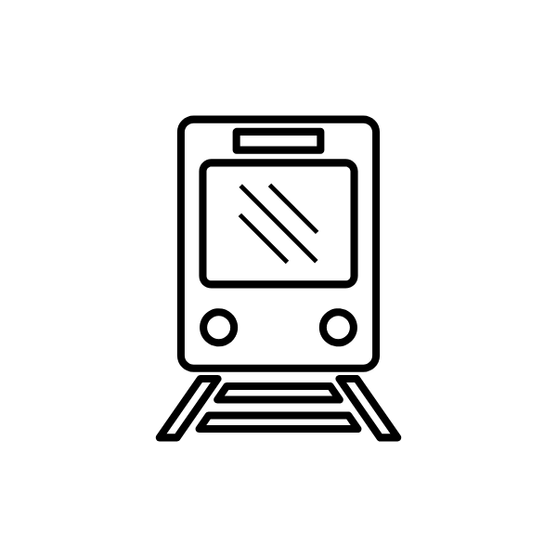
Ghent is easy to reach by train from all Belgian and European cities and is only half an hour from Brussels South Station (by 'IC' Inter City or 'IR' InterRegio train). Ghent has two stations: Gent-Sint-Pieters and Gent-Dampoort. At the main station, Gent-Sint-Pieters, you will find railway links to all the cities in Belgium.
Eurostar: London in 1,5 hours
Thalys: Paris or Amsterdam or Cologne in 2,5 hours

For more information on the train timetables:
for trains within Belgium or www.b-europe.com for international connections.

How do you get to the historic center from the station?
The city has a well-organised public transport system with an extensive tram and bus network. You can get anywhere in and around Ghent by tram or bus from early in the morning to late at night.
Tram 1 travels from the main railway station, Gent-Sint-Pieters, to the city centre every ten minutes. The following buses travel frequently to the centre: 3, 17, 18, 38, 39 (leave the bus at the Korenmarkt stop).

By car
Ghent is located on the intersection of two major European motorways:
1. the E17 connects Northern Europe to the South
2. the E40 runs from the North Sea right across to Eastern Europe.

From the E17 you take the 'Gent Centrum' exit.
On the E40, from the motorway intersection in Zwijnaarde, you first follow 'Antwerpen' (E17) and then take the 'Gent Centrum' exit.

Parking: closest public parking to 'Het Pand' is parking St-Michiels (P7), you can follow the P-route when entering the city.

By plane
Ghent is only 45 minutes from the international airport of Zaventem "Brussels Airport", where flights arrive from and depart to more than 70 destinations.
Brussels airport is a major European airport and has plenty of connections. It has direct highway and railway access to Ghent.

The airport is connected to the 3 railway stations in Brussels (South or Midi, Central and North stations) by 3 direct trains per hour.
Train tickets can be purchased at the airport (level -2).
There are several connections to Ghent.
So, if there are no direct trains from the airport to Ghent: first take a train to Brussels South, Central or North, and change for a train to Ghent.

For further details and timetables, visit Belgian Railways and Brussels Airport.
Brussels South / Charleroi airport is located in the south of Belgium and is 75 minutes drive from Ghent.
→ more than 20 bus connections from the airport to the capital every day
→ from there frequent train connections to Ghent
→ also bus connections from the airport to Charleroi-Sud railway station.
→ trains for Ghent can also be boarded there.
→ a ticket that combines the bus and train services can be purchased at the Airport Ticket Desk

